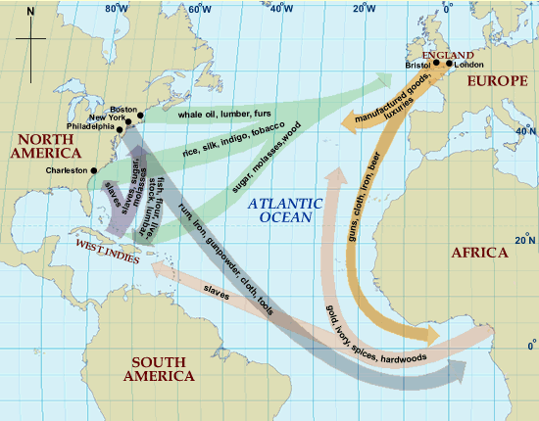

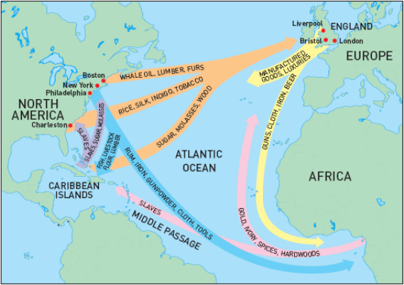

From New England, goods like ________________________________________________ were shipped to Europe. From the Middle and Southern colonies, things like ________________________________ __________________________________were shipped to Europe. From the Caribbean Islands, things like ________________________________________________ were shipped to Europe. Europe shipped things like __________________________________________________ back to New England and the other colonies.

The 13 colonies also shipped things like _______________________________________________________ ______________to Africa and things like _______________________________________________________ to the Caribbean Islands. In return, the 13 Colonies received things like __________________________ ___________________________________ from the Caribbean. The most important one of these things were the ______________ . These ______________________ originally came from ____________________ , and had went through the Middle Passage. Africa also shipped slaves to Europe in addition to things like ____________________________________________________. In return, Europe sent them ____________________________________________________________.

